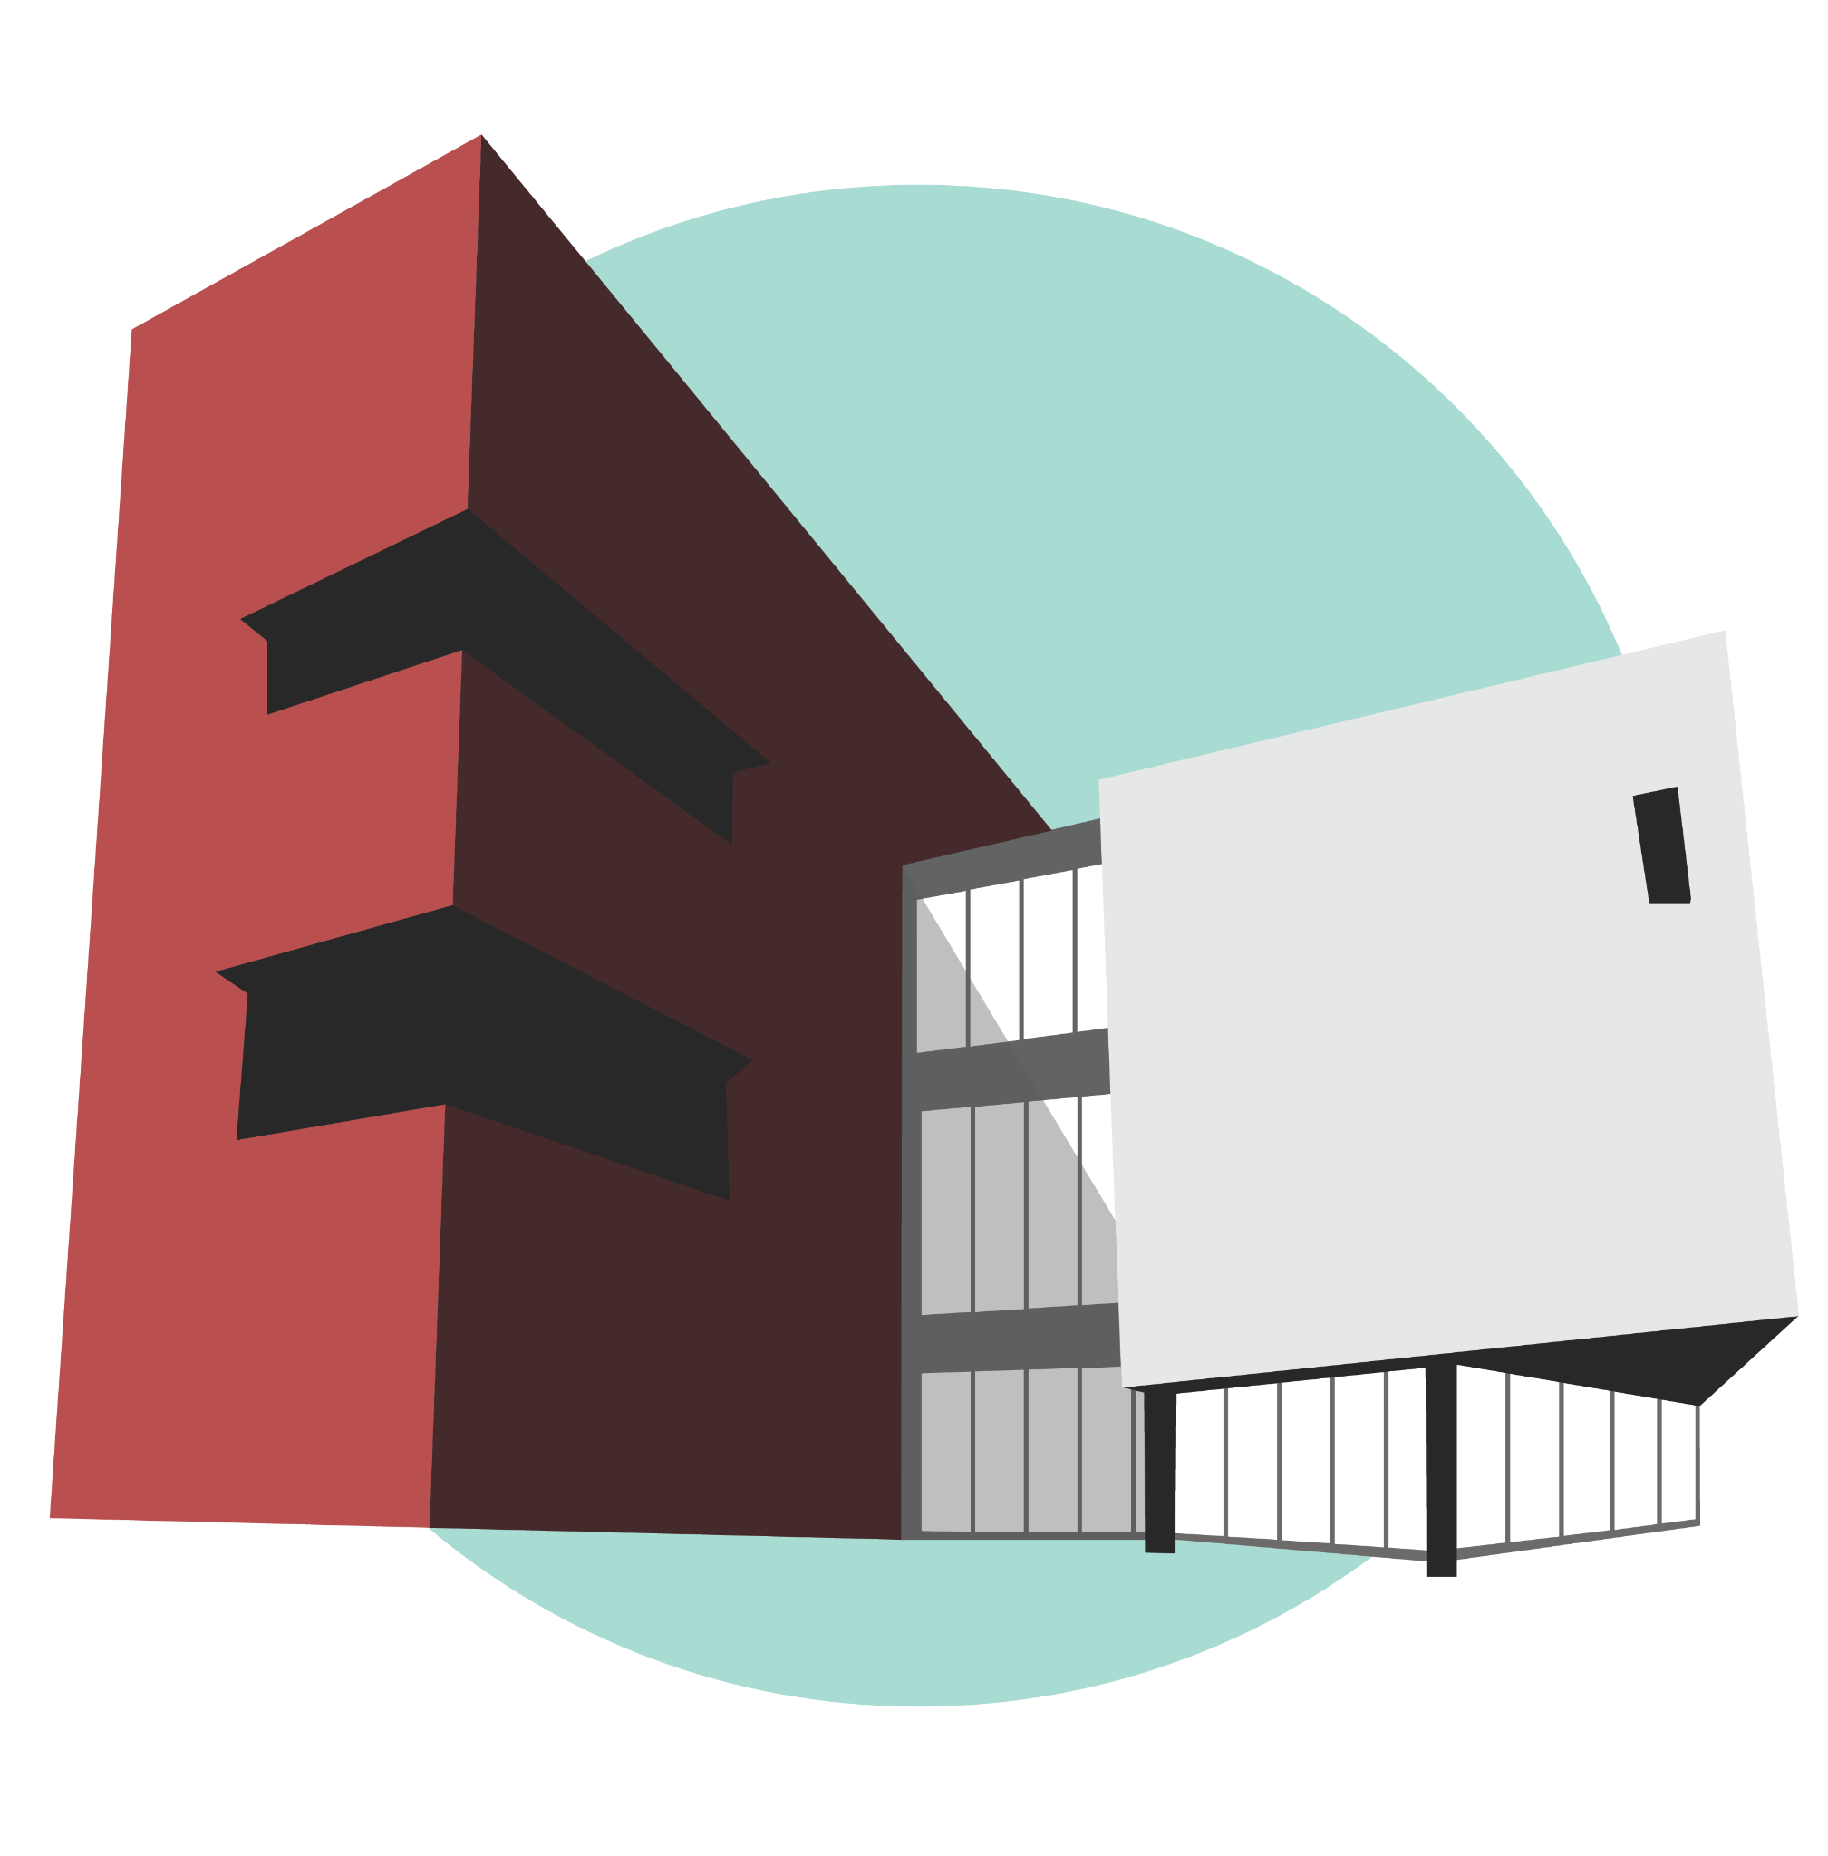
Call for Art Proposals 2026
Art4Trails public art installations on Rochester trails

Rochester Art Center is seeking proposals for three temporary outdoor, site-specific art installations at three locations along the trails near downtown Rochester as part of the Art4Trails program. One proposal for each site will be selected and the artist(s) will be awarded $3,000 per site, with $1,500 distributed upon selection and $1,500 after installation.

Artwork must be installed between June 1 and June 20, 2026. Applications open October 1, 2025, and close November 15, 2025 at 11:45 pm.

Rochester Park and Trail system
The Rochester trails provide a convenient way to do activities such as inline-skating, biking, running and walking – either for getting to work or for recreation and exercise. Rochester has 85+ miles of trails available for pedestrians, bikers, wheelchairs and strollers. Art4Trails site locations for temporary sculptures can be found here. They are at Silver Lake Park by the old fire station, Slatterly Park, and on a river landing near the waterfall sculpture at the end of 3rd St SE.

Eligibility
Artists 18 years of age or older living in Minnesota and neighboring states are invited to submit proposals individually or collaboratively. Students who do not meet the age requirement can participate by having a teacher or guardian sponsor a proposal. Priority will be given to artists who have never been chosen to receive an Art4Trails award before. Artists who currently have sculptures installed on the trail are not eligible to participate this year.

Selection Criteria
Proposals will be judged based on artistic merit as evidence by representation of past work, the proposal itself, and other supporting materials. A selection committee consisting of working artists, curators, arts professionals and a representative of the Parks and Recreation Department will review and select proposals by December 15, 2025.

The selection committee will consider the following criteria:
Artistic merit of the proposed work, including:
- Idea to be conveyed
- Key theme(s) engaged
- Appropriateness of media to idea
- Visual impact, including color, form and composition
- Harmony/compatibility with physical and social setting

Feasibility of the proposed work, including:
- Durability
- Public safety
- Risk assessment (risk will be assumed by the artist)
- Maintenance obligation

Ability of the artist to successfully complete the project, including:
- Training and experience
- Evidence of careful financial planning
- Technical competence

Review process
- Locations for artwork will be pre-selected and approved by the Rochester Parks and Recreation Department.
- The artwork must be of appropriate size and scale to fit in with its proposed surroundings.
- Responsibility for securing all necessary permissions and permits, fabrications, installation, maintenance, and removal of artwork is assumed by the artist.

Application Materials: Deadline November 15, 2025
Applicants must complete the application which requires the following:

Section 1 | Artist Information
- First and last name, address, city, state and contact information.
- Artist Resume/C.V. (one page maximum) in either Word or PDF format.

Section 2 | Project Proposal
- What is the idea or concept of the artwork? Describe what the project will consist of and/or look like.
- How will it be installed on location?
- What are your proposed installation and removal dates?
- Site preference (3 top choices). Locations can be found here.
  - Slatterly Park, River Landing, Mayo Park East or Silver Lake Fire Station
- Budget Outline: the $3,000 award will cover artist’s time and associated expenses for design and fabrication of the work. Artists should factor these costs into their budget. Sample budget: Click Here
  - Budget should include: rental of equipment, cost of materials, artists fees, etc.
  - Spreadsheet, Word or PDF format

Section 3 | Uploads
- Submit up to five images, sketches, models or renderings of what the project will look like, titled with the artist’s last name, first name, “proposal” and image number:

i.e.) Lastname_Firstname_Proposal_01.jpg, Lastname_Firstname_Proposal_02.jpg, etc.

- Images must be formatted digitally to the following specifications:
  - JPEG format
  - Each image less than 3 MB in size

Optional: include a separate Word or PDF document with descriptions of each piece (title, medium, size, etc.)

Submit your final application here on or before November 15, 2025, 11:45pm.
There is no fee to apply. Application and proposal materials will not be returned.

Site Information
Restrictions and considerations:
- Installations must be at least 2 feet from the trail.
- If a piece is meant to be interactive, it should be further from the trail to prevent visitors from blocking the trail.
- Artist is responsible for all maintenance and repairs if needed, e.g., vandalism.
- Art should be appropriate for its location. Site locations can be found here.

Duration of Installation
Duration is dependent on the proposal with a minimum of three months and a maximum of one year. Work is to be continuously displayed during this time. Rochester Parks and Recreation Department reserves the right to request that the artist remove or repair a work at any time during this period if circumstances require. At the end of the duration, the artist retains ownership of the work.

Notification
Artists will be notified about the result of their proposals via e-mail by December 15, 2025. At that time, artists selected for the temporary installations will receive $1,500 of the award to purchase materials and work on the project. The final $1,500 will be awarded upon installation of the art. Inquiries about status of applications will not be accepted after the November 15, 2025 application deadline.

Art Sales
The art can be for sale; however, the artwork will remain on display on the trail as per contract signing with the artist.

Unveiling Event
An unveiling event is proposed for June 2026.
For further information about the application process, please contact Kalianne Morrison: kmorrison@rochesterartcenter.org

