ROCHESTER ART CENTER | 30 Civic Center Drive SE, Ste 120, Rochester, MN 55904

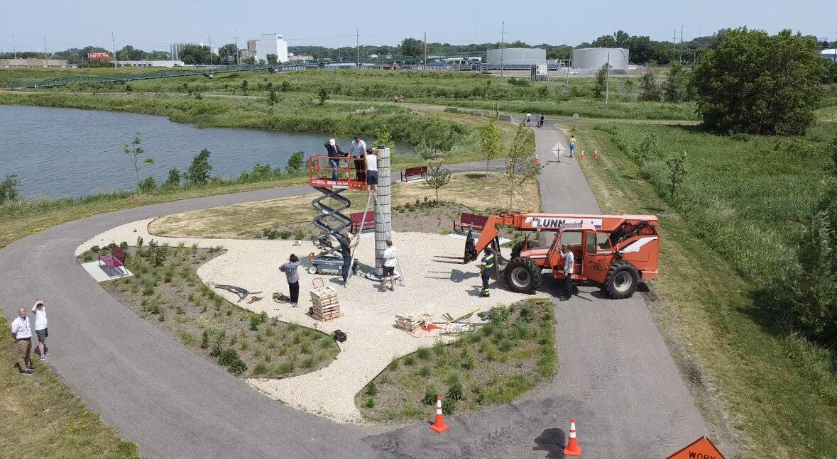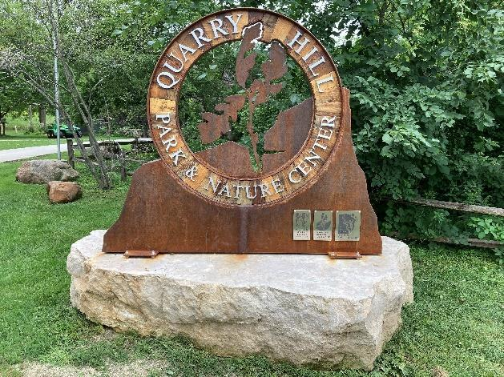
Installation of Pillar Sundial by C. Anthony Huber, Quarry Hill Art Sign installed by Blue Rhino
Cascade Lake Regional Park, 2021. Studio at Quarry Hill Regional Park, 2021

Call for Art Proposals 2024
The Rochester Park and Recreation Department with support from Rochester Art Center is seeking artists and/or artist groups to design and fabricate two works of art for our new regional park in southwest Rochester. The new artwork is to be installed in 2024. One proposal will be selected for each project and the artist(s) will be awarded the dollar amounts outlined below. The two pieces will be considered separate projects. Artists can submit for one or both of the pieces.

Artwork will be installed by October 31, 2024. Applications open January 10, 2024, and close February 10, 2024 at 11:45 pm.

Background
A master planning process initiated in 2003 by the City of Rochester Park and Recreation Department and finished in 2005 laid the groundwork by which gravel mining areas along Cascade Creek would be transformed into a premier multi-use park. The vision created was for a park that built on the area’s water and natural resource features, its history as a mining site, and for a lake which is at the heart of recreational activities.

Cascade Lake Regional Park, located at 88 23rd Avenue SW has since grown incrementally over the years, adding bike trails, bridges, wildlife habitat, streambank and wetland restoration. In 2015 the park was designated as a MN Park and Trail of Regional Significance, allowing for 1.5 million dollars in grant funding through the Greater Minnesota Parks and Trail Commission in 2017.

From 2017-2020 5.5 acres of park were more intensively developed and feature children’s play areas, a pavilion for outdoor activities, walking trails, a beach, paved parking lot with sustainable stormwater treatment, natural gardens, open turf areas for active play, and pedestrian bridges connecting the park with the neighborhoods to the south and east.

Thanks to private and public funding the 246 acre park now resembles the vision set out in 2005. Future phases to the park will include an amphitheater for outdoor concerts, a visitor center, beach house, additional picnic areas and trails, a fishing pier, boathouse and boat launches.

Project #1 | Roundabout Artwork
Artwork number one will be located in the roundabout located near the new Cascade Lakeside building. The artwork should reflect the context of the park as a natural amenity within an urban setting. It should also be influenced by the park's history as a sand and gravel quarry and the importance of Cascade Creek (which flows through and around the lake) as an important water resource within the community. Budget: $50,000.
Apply to this project online: https://forms.gle/stUhRxZfa2XSF1DS7

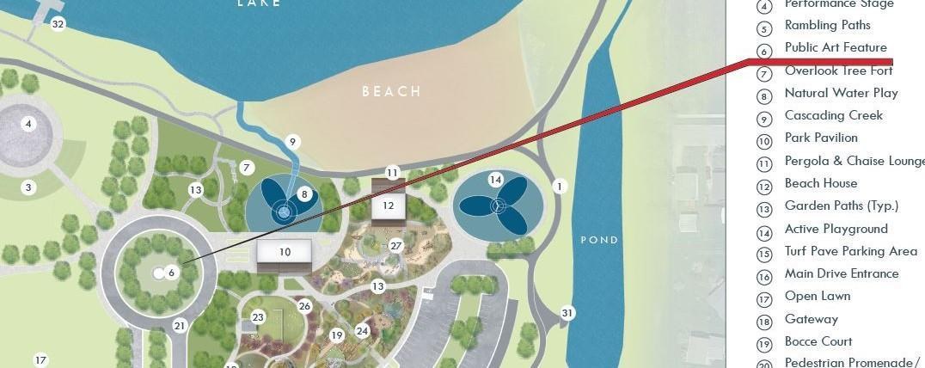

Project #2 | Entrance Sign
Project number two is a park identification sign located on the north side of 23rd Avenue near the entrance to the park. As with project #1 the entrance sign should also be influenced by the park's history as a sand and gravel quarry and the importance of Cascade Creek (which flows through and around the lake) as an important water resource within the community.

The sign should read “Cascade Lake Park” and contain the logos for Rochester Park and Recreation, and Legacy Amendment. The successful sign concept should ultimately comply with the City of Rochester Zoning Ordinance and Unified Development Code Section 60.400.110 Signs. Permits for signage installation will likely be required. Park and Recreation Staff will aid the successful applicant in compliance with sign regulations as necessary. Budget: $20,000
Apply to this project online: https://forms.gle/F8oKoeS2dgMPUT9r6

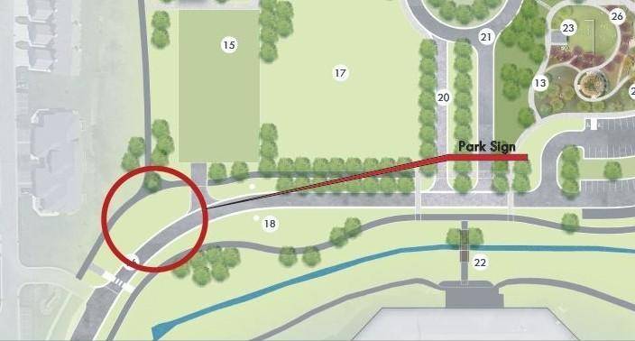

Eligibility
Artists 18 years of age or older living in Minnesota and neighboring states are invited to submit proposals individually or collaboratively. Individuals who do not meet the age requirement can participate by having an age appropriate individual sponsor and be responsible for the proposal.
Selection Criteria
Proposals will be judged based on artistic merit as evidenced by representation of past work, the proposal itself, and other supporting materials. A selection committee consisting of working artists, curators, arts professionals and a representative of the Parks and Recreation Department will review and select proposals by March 15, 2024. The Board of Parks and Recreation will ultimately provide their approval for the project to proceed.

Link to webpage for more information: https://www.rochesterartcenter.org/art4trails

Projects must be in place before October 31, 2024.

The selection committee will consider the following criteria:
Artistic merit of the proposed work, including:
- Idea to be conveyed
- Key theme(s) engaged
- Appropriateness of media to idea
- Visual impact, including color, form and composition
- Harmony/compatibility with physical and social setting

Feasibility of the proposed work, including:
- Durability
- Public safety
- Maintenance obligation

Ability of the artist to successfully complete the project, including:
- Training and experience
- Evidence of careful financial planning
- Technical competence

Review process
- Locations for artwork will be pre-selected and approved by the Rochester Parks and Recreation Department.
- The artwork must be of appropriate size and scale to fit in with its proposed surroundings.
- Responsibility for securing all necessary permissions and permits, fabrications, installation, maintenance, and removal of artwork is assumed by the artist.

Application Materials: Deadline Saturday, February 10, 2024
Applicants must complete the application which requires the following:

Section 1 | Artist Information
- First and last name, address, city, state and contact information.
- Artist Resume/C.V. (one page maximum) in either Word or PDF format.

Section 2 | Project Proposal
- What is the idea or concept of the piece and how does it relate to the park's history as a sand and gravel quarry and the importance of Cascade Creek (which flows through and around the lake) as an important water resource within the community? Describe what the project will look like.
- What material(s) is the artwork made of?
- How will it be installed on location?
- Budget Outline:
Project #1 | Roundabout Artwork is located within the roundabout (see Master Plan) and will have a $50,000 award which covers the artist’s time and associated expenses for design and fabrication of the artwork. Artists should factor these costs into their budget.
  - Budget should include: rental of equipment, cost of materials, artists fees, installation, etc.
  - Word or PDF format.

Project #2 | Entrance Sign is a park identification sign located on the northside of 23rd Avenue near the entrance to the park (see Master Plan) will have a $20,000 award which covers the artist’s time and associated expenses for design and fabrication of the work. Artists should factor these costs into their budget.
  - Budget should include: rental of equipment, cost of materials, artists fees, installation, etc.
  - Word or PDF format

Section 3 | Uploads
- Submit up to five images, sketches, models or renderings of what the project(s) will look like, titled with the artist’s last name, first name, “proposal” and image number: .

i.e. Lastname_Firstname_Proposal_01.jpg, Lastname_Firstname_Proposal_02.jpg, etc.

- Images must be formatted digitally to the following specifications:
  - JPEG format
  - Each image less than 3 MB in size

Optional: include a separate Word or PDF document with descriptions of each piece (title, medium, size, etc.)

Submit your final application on or before February 10 2024, 11:45pm.
There is no fee to apply. Application and proposal materials will not be returned.
Apply to project #1 | Roundabout Artwork: https://forms.gle/LDxbio7PrgNSUAQV8
Apply to project #2 | Entrance Sign: https://forms.gle/F8oKoeS2dgMPUT9r6

Notification
Artists will be notified about the result of their proposals via e-mail by March 15, 2024. Upon signing of a contract for Project #1 the artist(s) will receive $35,000 of the award to purchase materials and work on the project. The final $15,000 will be awarded upon installation of the art. For Project #2 the artist(s) will receive $15,000 of the award to purchase materials and work on the project. The final $5,000 will be awarded upon installation of the art. Inquiries about status of applications will not be accepted after the February 10, 2024 application deadline.

Duration of Installation
- Both pieces will be permanently installed and become property of the City of Rochester.

Site Map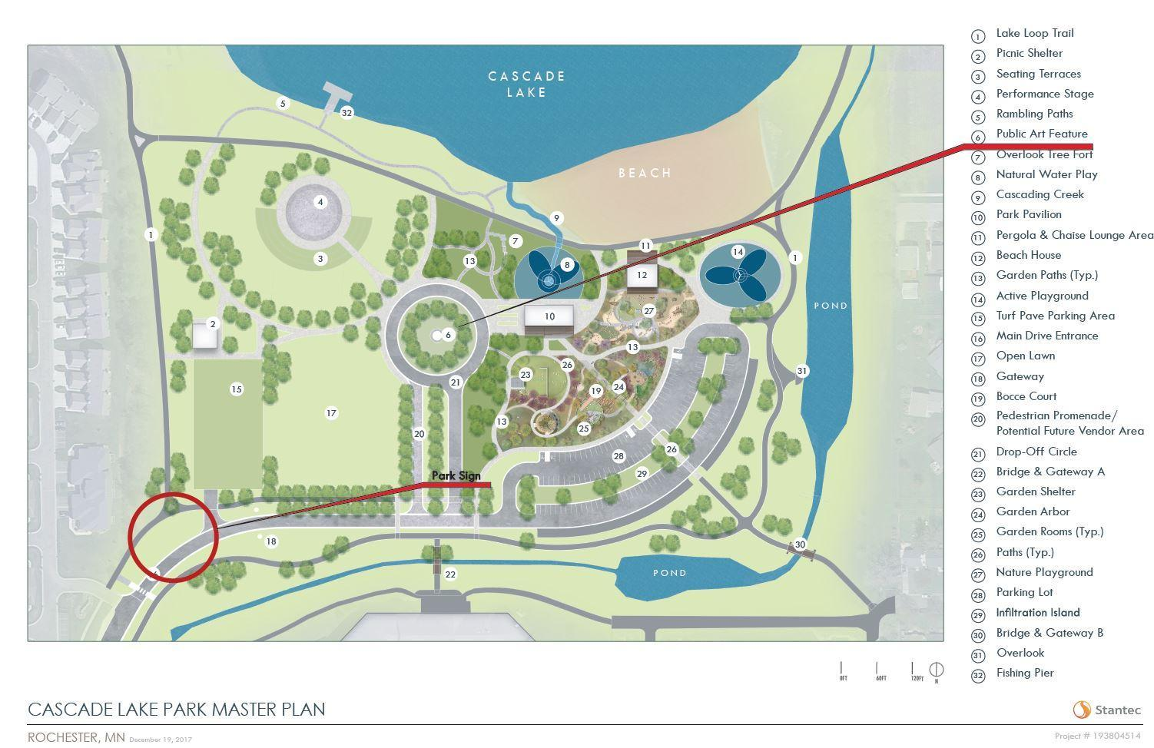
About Rochester Art Center
Rochester Art Center is a museum of contemporary art located along the Zumbro River in the heart of historic downtown Rochester, MN. Founded in 1946, the Art Center hosts an ongoing schedule of exhibitions of work by local, regional, national, and international artists; dynamic educational programs for all ages; and an array of community partnerships and visitor engagement initiatives. Through world-class exhibitions and programs, the Art Center presents a welcoming, integrated, and diverse experience that encourages questioning, creativity, and critical thinking.

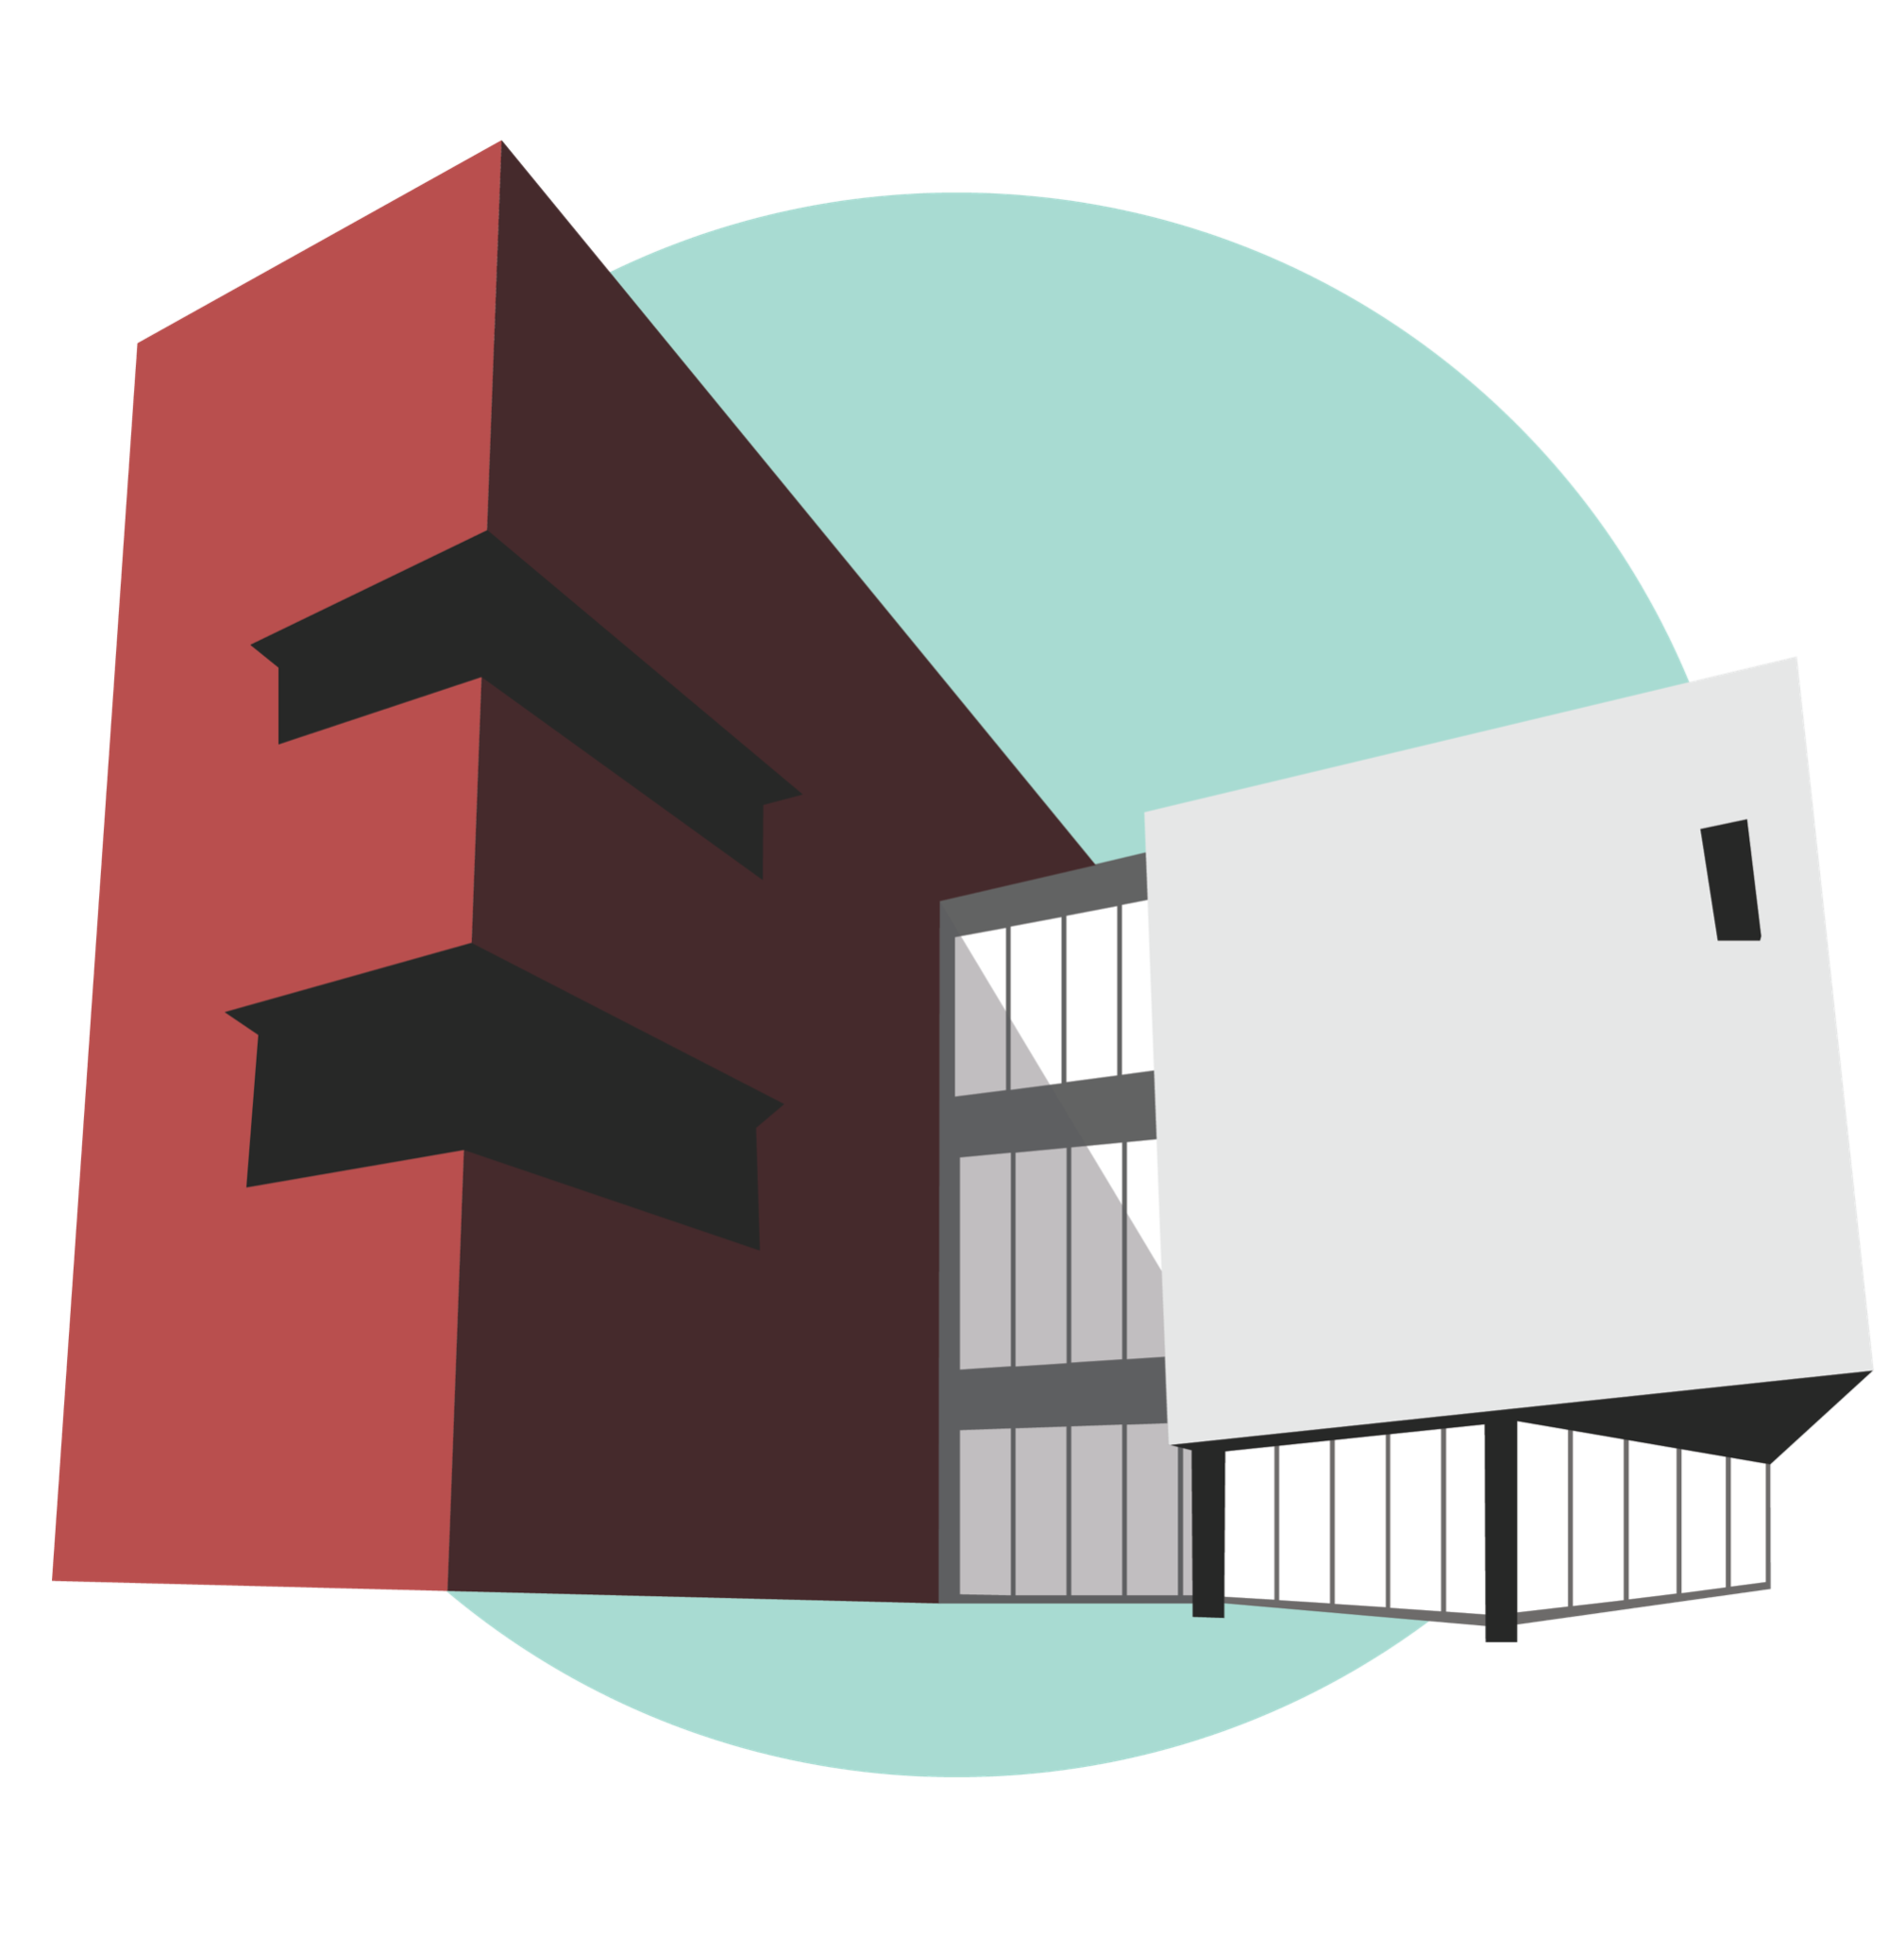
CONTACT Kalianne Morrison, Advancement Coordinator | kmorrison@rochesterartcenter.org
